DATA ANALYTICS ASSIGNMENT 3

LANKA DIVYA LAKSHMI BHARATHI

20NN1A0522

IV B.TECH (CSE)

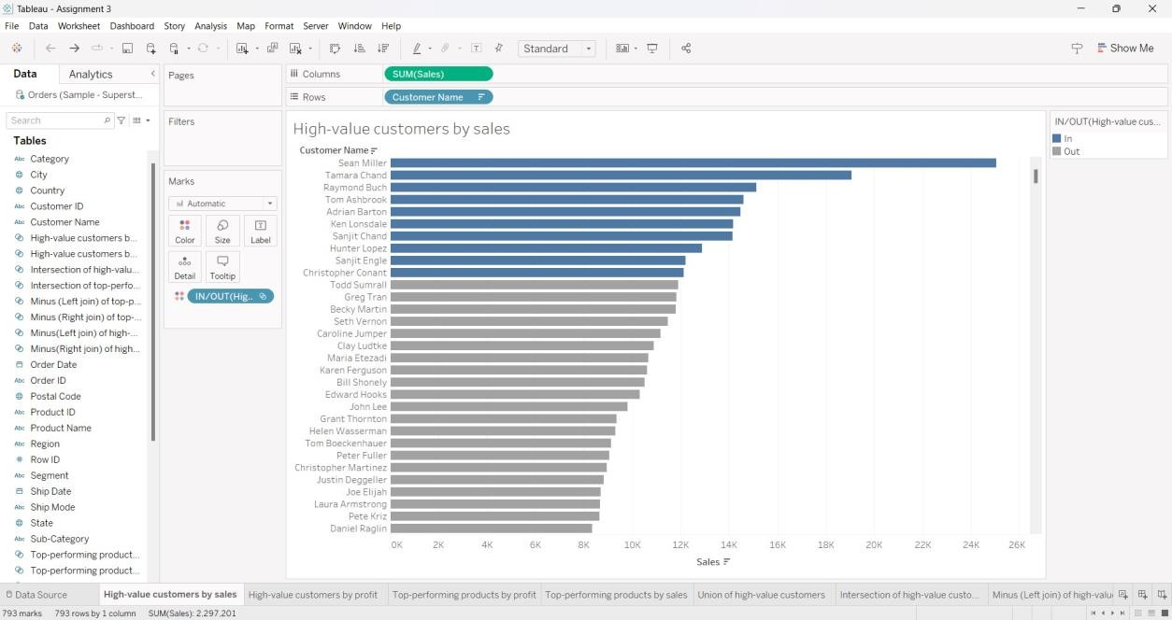VIGNAN’S NIRULA INSTITUTE OF TECHNOLOGY AND SCIENCE FOR WOMEN (VNITSW)

DATASET : [Sample - Superstore.xls](https://docs.google.com/spreadsheets/d/1Vmsk3xJ_qp69U0AZzCpNybqX0AP4KSon/edit#gid=972120833)

* Define at least two sets based on specific criteria from your dataset (e.g., high-value customers, top-performing products).
* Experiment with combining sets using UNION, INTERSECT, and MINUS operations.
* Create 2 Calculation field using any aggregate function
* Create any 3 visualization using quick Table Calculations

HIGH-VALUE CUSTOMERS BY SALES

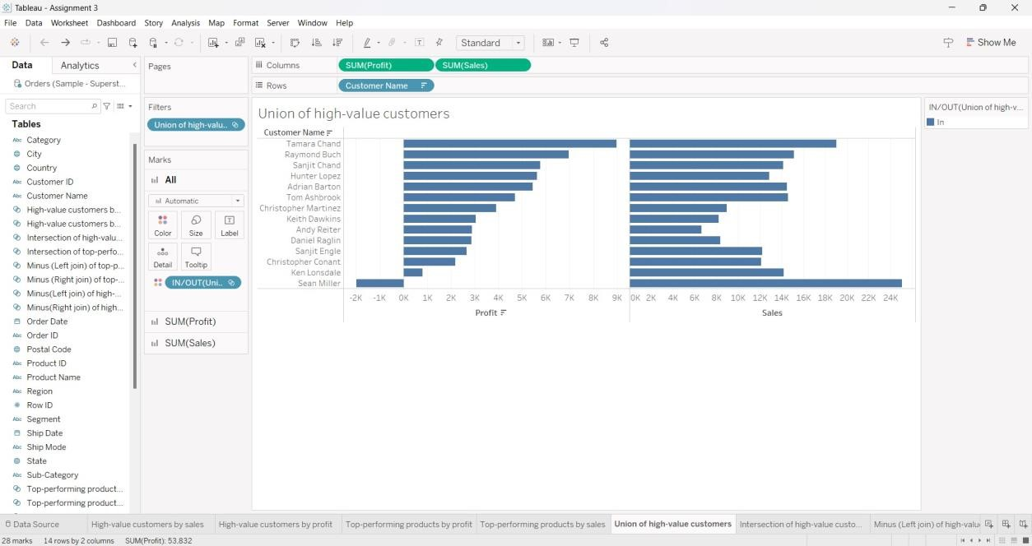HIGH-VALUE CUSTOMERS BY PROFIT

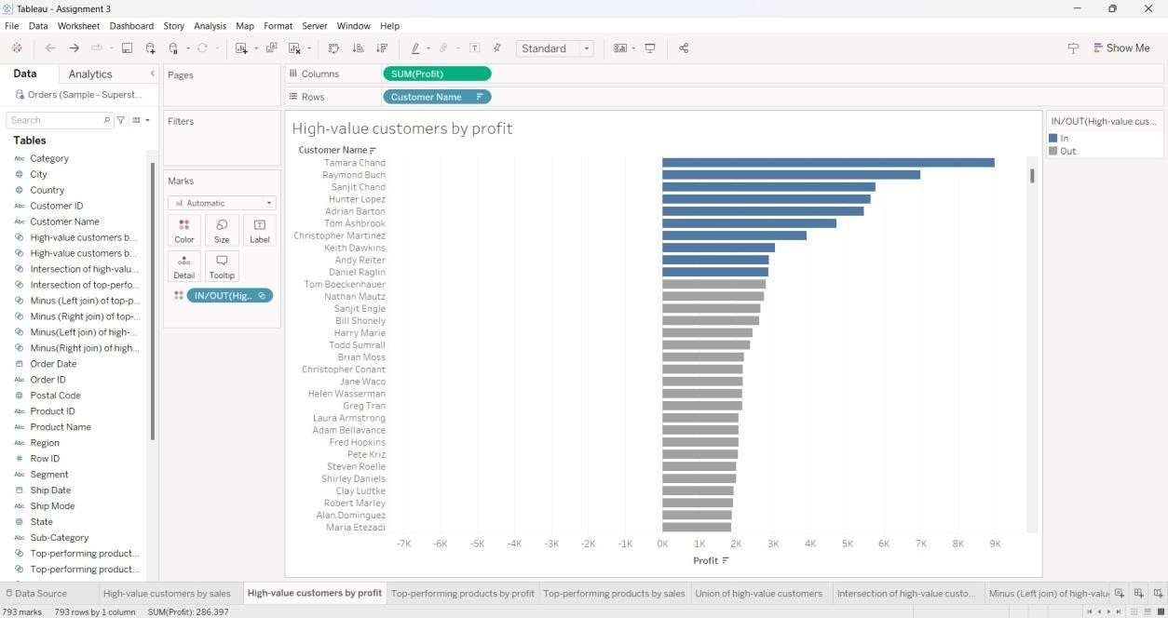

UNION OF HIGH-VALUE CUSTOMERS INTERSECTION OF HIGH-VALUE

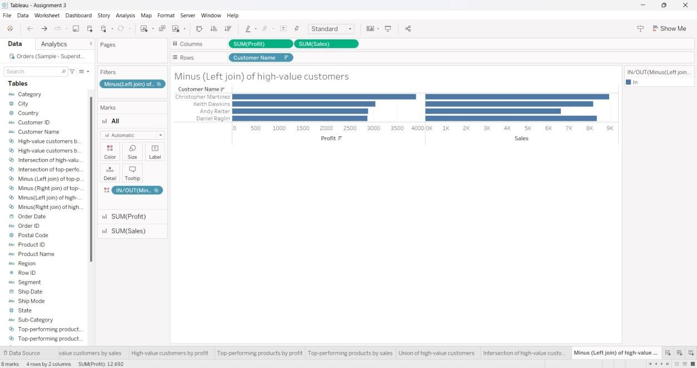CUSTOMERS

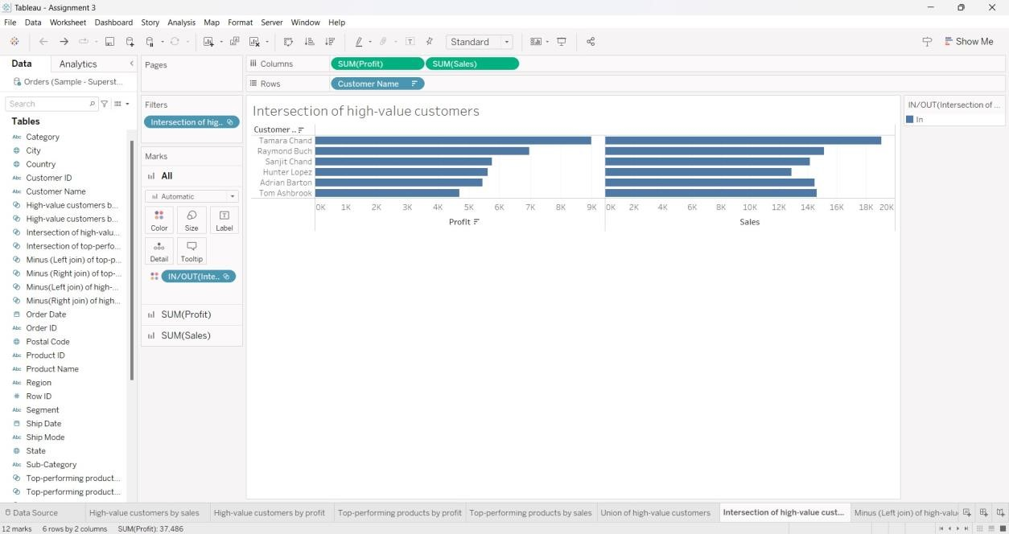

MINUS (LEFT JOIN) OF HIGH-VALUE CUSTOMERS MINUS (RIGHT JOIN) OF

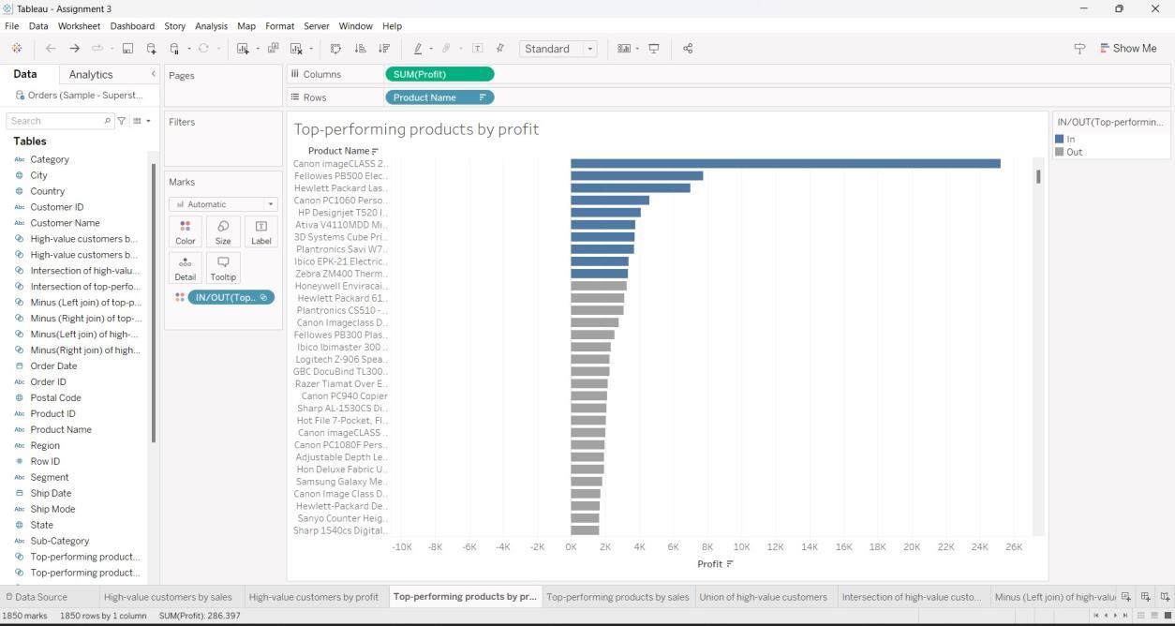HIGH-VALUE CUSTOMERS

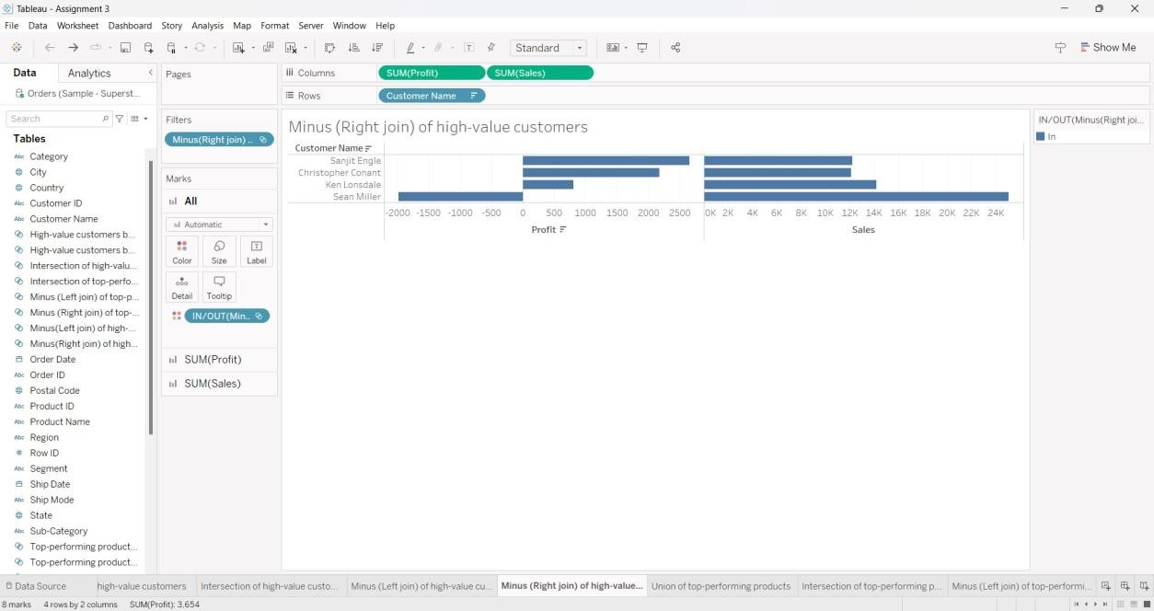

TOP-PERFORMING PRODUCTS BY PROFIT TOP-PERFORMING PRODUCTS

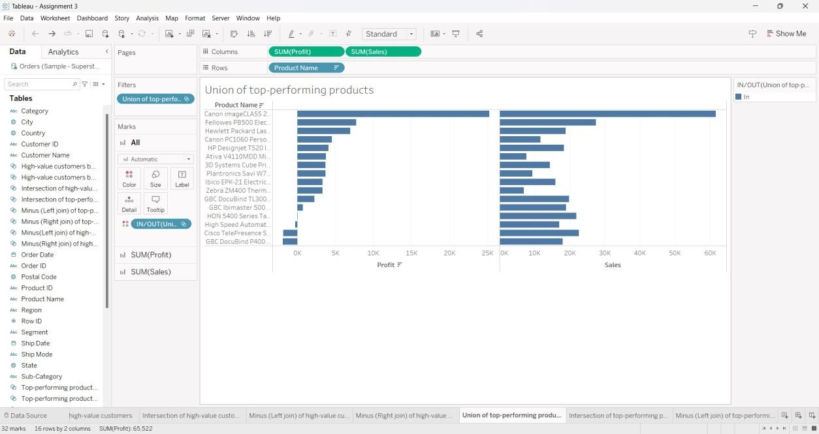BY SALES

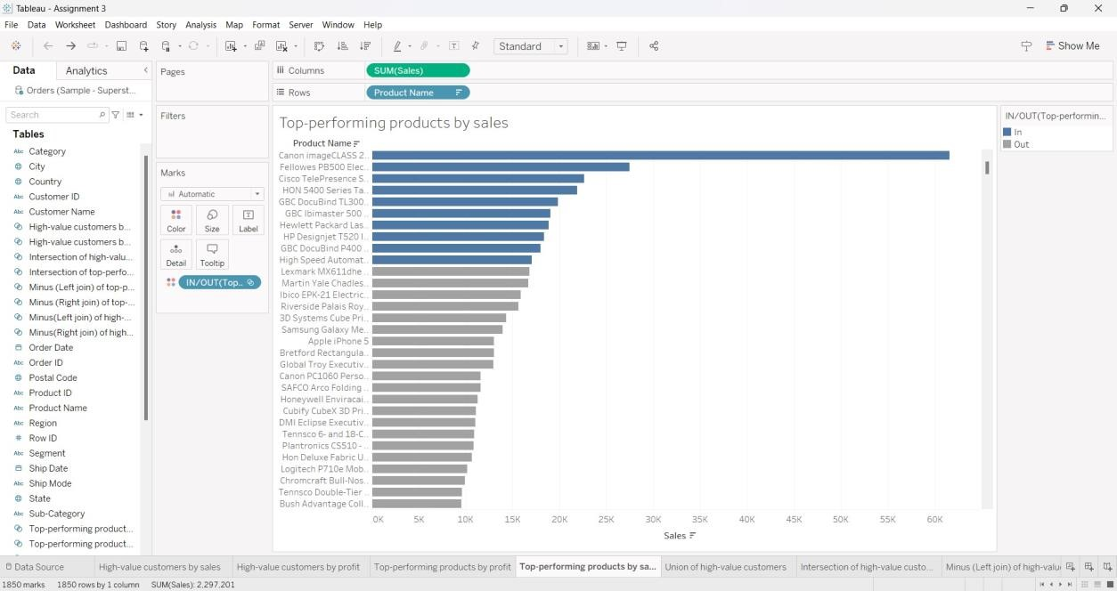

UNION OF TOP-PERFORMING PRODUCTS INTERSECTION OF TOP-

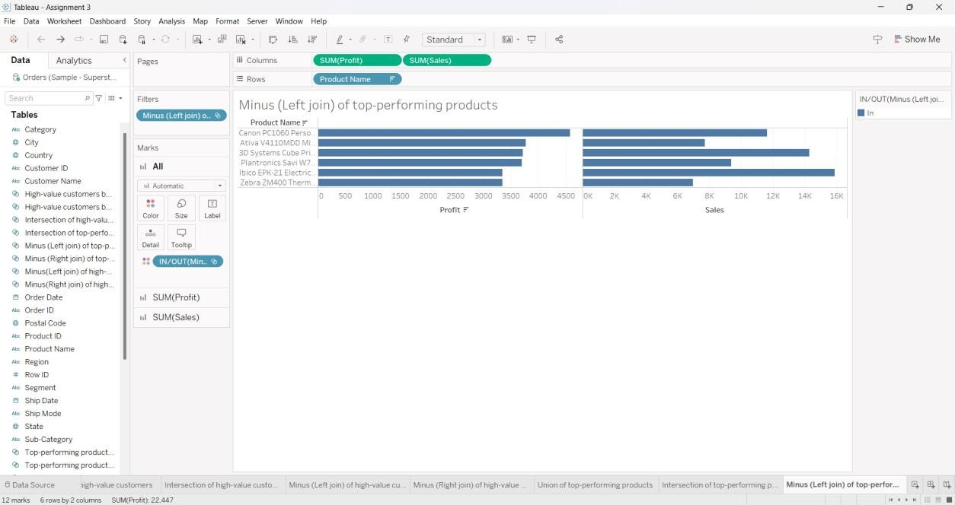PERFORMING PRODUCTS

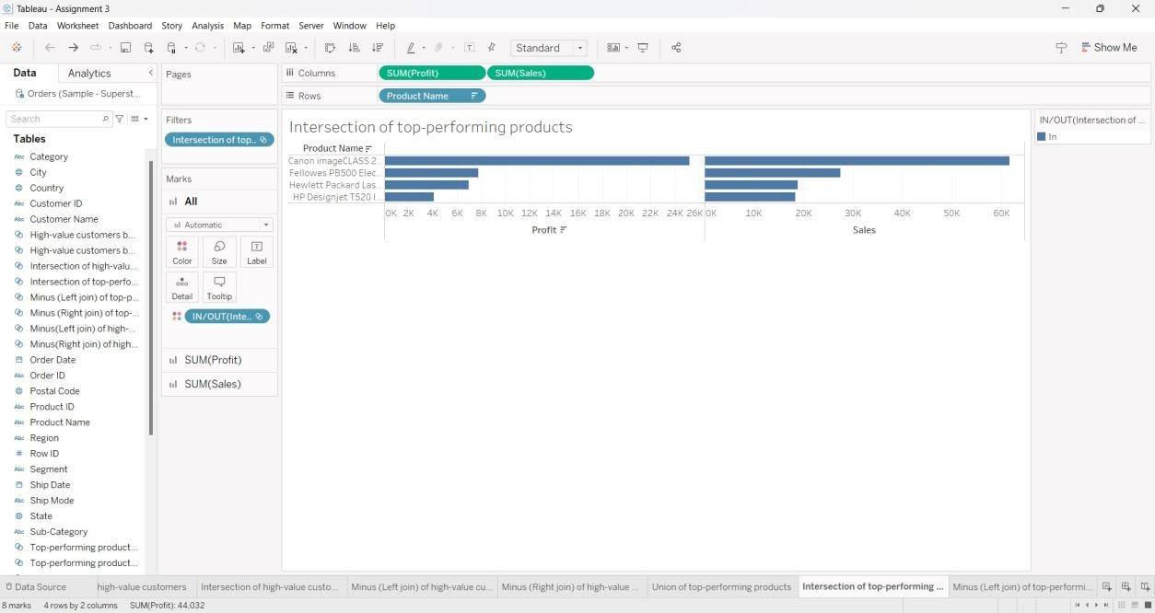

MINUS (LEFT JOIN) OF TOP-PERFORMING PRODUCTS MINUS (RIGHT JOIN)

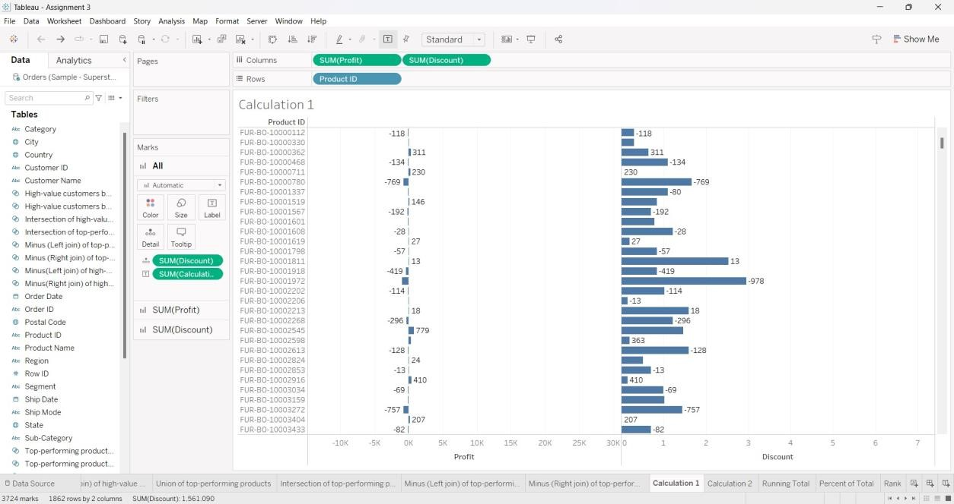OF TOP-PERFORMING PRODUCTS

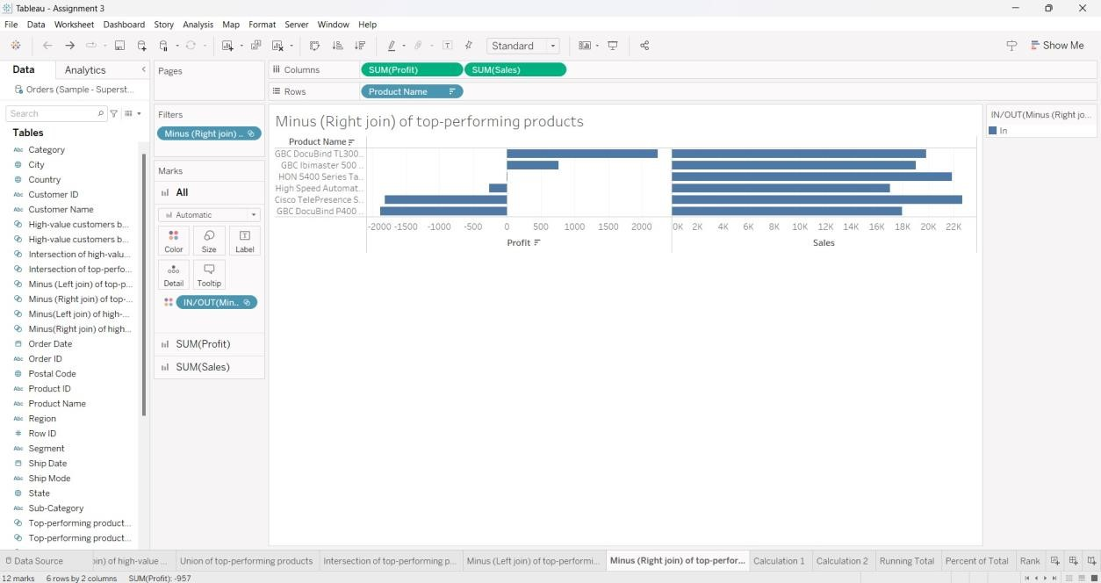

CALCULATED FIELD - 1

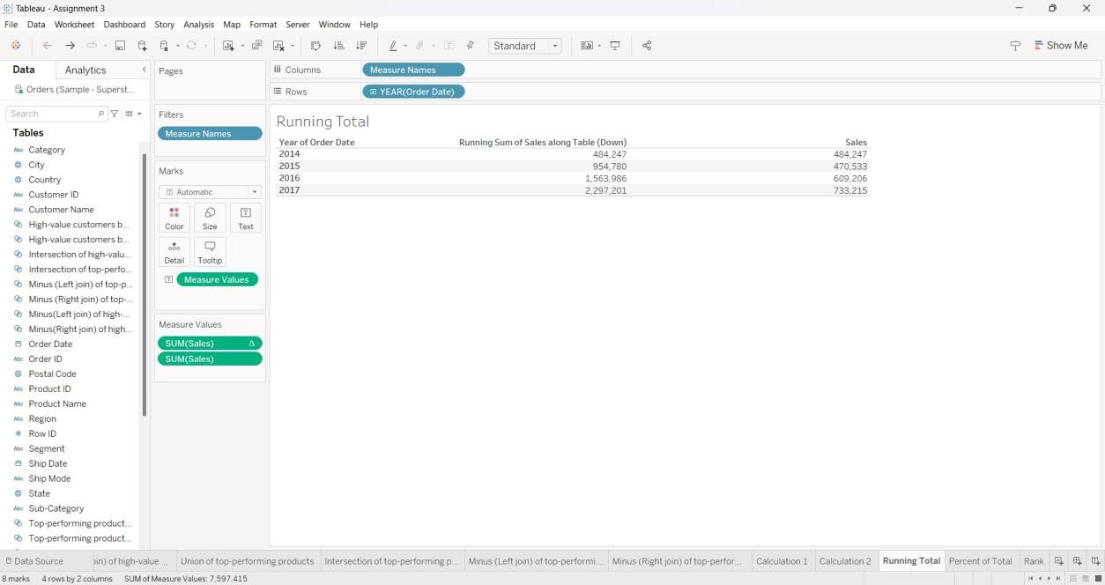CALCULATED FIELD - 2

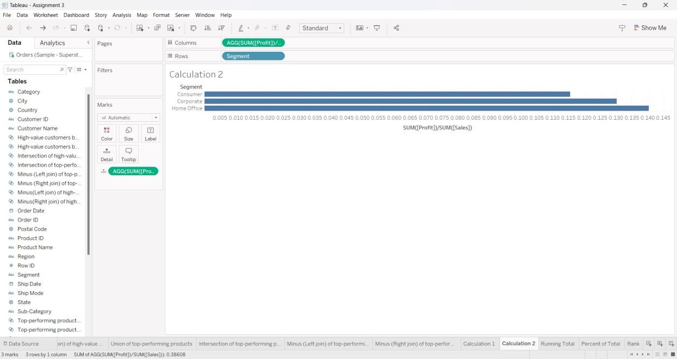

QUICK TABLE CALCULATIONS:

RUNNING TOTAL

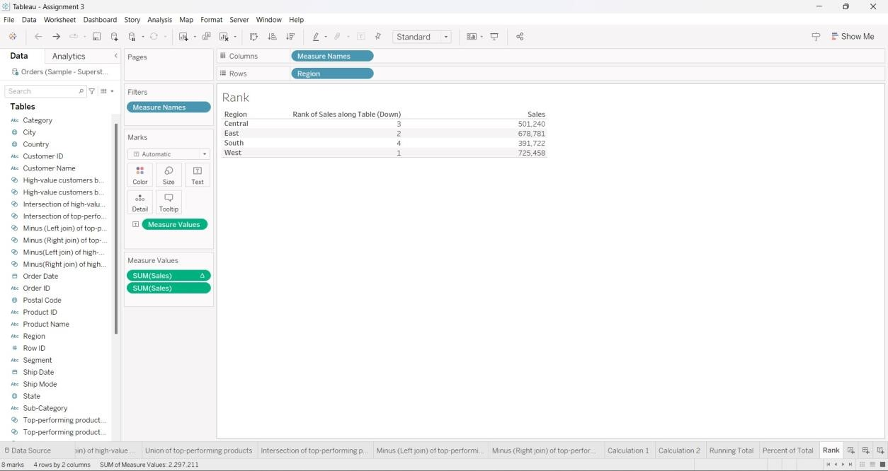PERCENT OF TOTAL

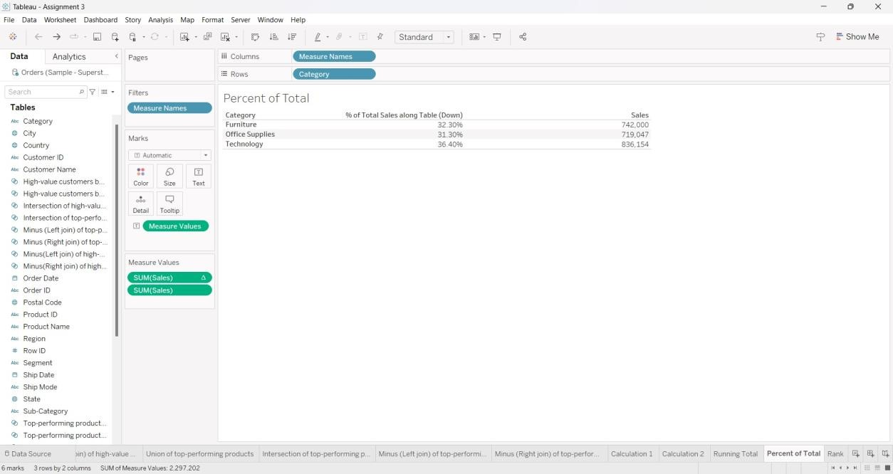

RANK